SKILLS ASSESSMENT APPLICATION-STANDARD OPERATING PROCEDURE

Document Control
Document No. | SOP-CI-001
Version | 1.0
Department | Migration Services
Effective Date | ________________
Approved By | ________________

Purpose
This Standard Operating Procedure (SOP) establishes the process for assessing, preparing, lodging, and monitoring Skills Assessment applications. It ensures that all applications are handled consistently, accurately, and in accordance with the requirements of the relevant assessing authority and Australian migration legislation.

Scope
This SOP applies to all consultants, migration agents, and processing staff involved in Skills Assessment applications for both onshore and offshore clients.
The procedure covers:
- Initial client enquiry
- Eligibility assessment
- Occupation identification
- Document collection
- Skills Assessment application preparation
- Lodgment
- Outcome management
- Client communication
- Record management

Roles and Responsibilities

Consultant
The Consultant is responsible for:
- Conducting the initial client consultation.
- Determining the client's background, qualifications, and work experience.
- Completing the Client Inquiry Form.
- Registering the client in the Client Engagement Log.
- Creating the client's folder.
- Endorsing the case to the Migration Agent.
- Collecting all required documents from the client.
- Following up outstanding documents.
- Uploading completed documents to the client's folder.
- Coordinating with the Skills Assessment Point Person throughout the application process.
- Updating the client regarding document requirements and application progress.

Migration Agent
The Migration Agent is responsible for:
- Reviewing the consultation notes and Client Inquiry Form.
- Determining the client's nominated occupation.
- Identifying the appropriate Skills Assessing Authority.
- Confirming the client's eligibility for a Skills Assessment.
- Providing technical migration advice.
- Endorsing the matter to the Skills Assessment Point Person.

Skills Assessment Point Person
The Skills Assessment Point Person is responsible for:
- Reviewing all client documents.
- Confirming that documentation meets the assessing authority's requirements.
- Preparing the Skills Assessment application.
- Requesting additional documents where necessary.
- Lodging the Skills Assessment application.
- Monitoring application progress.
- Responding to Requests for Further Information (RFI), if applicable.
- Advising the Consultant and Migration Agent of the application outcome.
- Maintaining complete records within the client's file.

Tools and Systems
The following systems shall be used during the Skills Assessment process:
- Client Engagement Log
- Client Inquiry Form
- Client Digital Filing System
- Skills Assessment Checklist
- Document Request Checklist
- Google Drive / Internal Document Storage
- Email
- Assessing Authority Online Portals
- Internal Case Tracking System

Document Management

Every client must be registered in the Client Engagement Log to generate a Unique Client Code

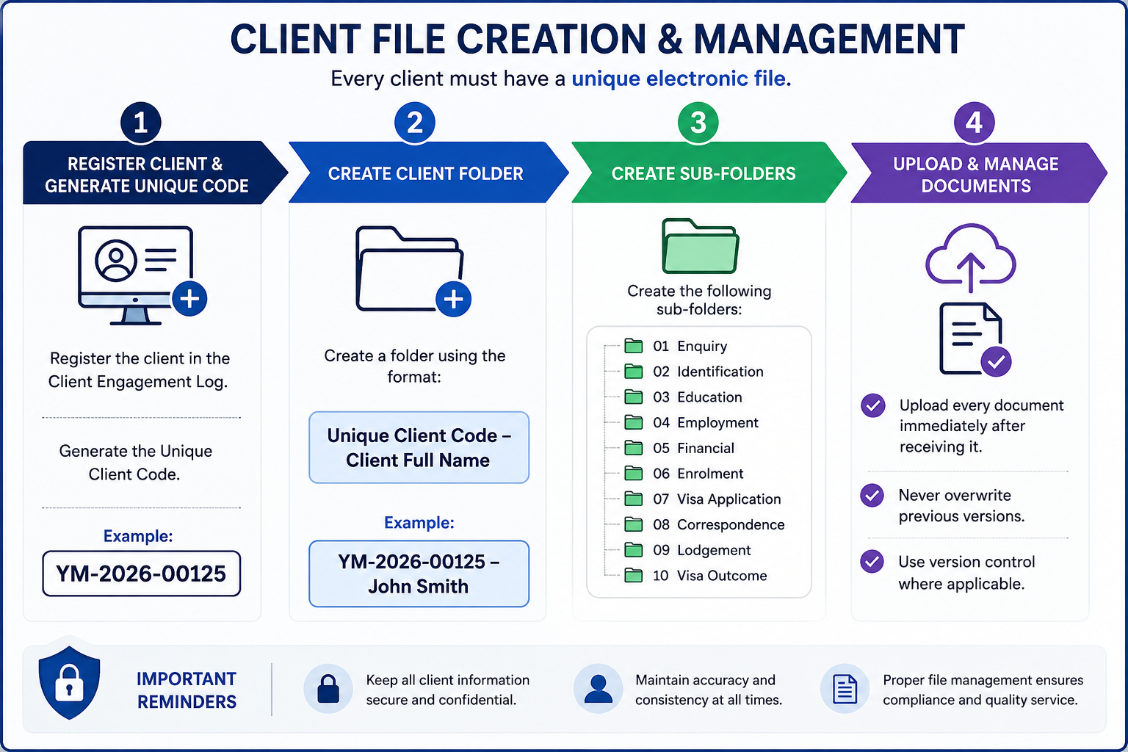

Step | Process | Procedure
1 | Register Client | Register the client in the Client Engagement Log and generate a Unique Client Code.  Example: YM-2026-00125
2 | Create Client Folder | Create a client folder using the following naming convention:  Unique Client Code – Client Full Name  Example: YM-2026-00125 – John Smith
3 | Create Sub-Folders | Create the following folders within the client's main folder:  01. Enquiry  02. Identification  03. Education  04. Employment  05. Financial  06. Enrolment  07. Visa Application  08. Correspondence  09. Lodgement  10. Visa Outcome
4 | Upload & Maintain Documents | Upload all client documents immediately upon receipt.  • Do not overwrite previous versions.  • Apply version control where necessary.  • Ensure all documents are saved in the correct sub-folder.

- SKILLS ASSESSMENT PROCESSING PROCEDURE

Step | Process | Responsibility | Procedure
1 | Client Enquiry | Consultant | Receive client enquiry and schedule an initial consultation.
2 | Initial Consultation | Consultant | Assess the client's education, employment history, occupation, and migration goals.
3 | Complete Inquiry Form | Consultant | Complete the Client Inquiry Form with all relevant client information.
4 | Register Client | Consultant | Register the client in the Client Engagement Log and generate the Unique Client Code.
5 | Migration Assessment | Migration Agent | Review the client's profile and determine the most appropriate nominated occupation and assessing authority.
6 | Case Endorsement | Migration Agent | Endorse the case to the Skills Assessment Point Person.
7 | Document Checklist | Skills Assessment Point Person | Prepare the document checklist based on the relevant assessing authority's requirements.
8 | Document Collection | Consultant | Request and collect all required documents from the client.
9 | Document Review | Skills Assessment Point Person | Review documents for completeness, accuracy, and compliance. Request additional documents if required.
10 | Application Preparation | Skills Assessment Point Person | Prepare the Skills Assessment application and supporting documentation.
11 | Migration Agent Review | Migration Agent | Review the completed application before submission, if required.
12 | Lodgement | Skills Assessment Point Person | Lodge the application through the relevant assessing authority's online portal.
13 | Client Update | Consultant | Inform the client that the application has been lodged and provide acknowledgement where applicable.
14 | Application Monitoring | Skills Assessment Point Person | Monitor the application until a decision is received.
15 | Further Information | Consultant & Point Person | If additional documents are requested, coordinate with the client and submit within the required timeframe.
16 | Outcome | Skills Assessment Point Person | Receive the outcome and advise the Migration Agent and Consultant.
17 | Client Notification | Consultant | Inform the client of the Skills Assessment result and discuss the next migration pathway.
18 | File Closure | Consultant | Save all final documents and update the Client Engagement Log.
- Quality Control Checklist
Before lodging the application, confirm that:
- Client identity has been verified.
- Client Inquiry Form has been completed.
- Occupation has been confirmed by the Migration Agent.
- Correct Skills Assessing Authority has been identified.
- All educational documents have been collected.
- All employment documents have been collected.
- English language requirements have been reviewed (if applicable).
- Required translations have been provided.
- All documents are clear, complete, and certified where required.
- Application has been reviewed before lodgement.
- Lodgement confirmation has been saved.
- Client has been notified of the lodgement.
- Client folder has been updated

8. Compliance and Disclosure
Yale Migration is committed to maintaining the highest standards of professionalism, ethical conduct and compliance with Australian migration legislation.
All staff involved in Graduate Visa applications must comply with the following requirements:

Legislative Compliance
- Comply with all applicable Australian migration legislation, regulations and policy requirements.
- Follow all requirements of the Department of Home Affairs when preparing and lodging visa applications.
- Ensure that all information provided in a visa application is accurate, truthful and supported by appropriate evidence.

Professional Responsibilities
- Only a Registered Migration Agent may provide migration advice or make legal representations regarding visa matters.
- Consultants and administrative staff must not provide migration advice unless authorised to do so.
- Any complex migration issues must be referred to the Registered Migration Agent.

Client Confidentiality
- Protect all client information in accordance with Australian privacy requirements and the agency's privacy policy.
- Client information must only be accessed by authorized staff for legitimate business purposes.
- Client documents must be stored securely within the agency's approved document management system.

Accuracy and Record Management
- Maintain complete, accurate and up-to-date client records always.
- Record all client communications, advice provided, and documents received or submitted.
- Ensure all electronic files follow the agency's document naming and filing procedures.

Fee Disclosure
Before commencing any work, the client must receive clear written information regarding:
- Professional service fees.
- Government Visa Application Charges (VAC).

Client Acknowledgement
Before visa lodgment, the client must acknowledge that:
- All information provided is true, complete and accurate.
- They have reviewed and approved the final visa application.
- They understand their obligations as a Student Visa holder.
- They understand that providing false or misleading information may result in visa refusal or cancellation.

Visa Outcome Disclaimer
Yale Migration will prepare and manage every application with due skill, care and diligence. However, the approval or refusal of any visa application is solely at the discretion of the Department of Home Affairs.
Neither Yale Migration nor the Registered Migration Agent can guarantee the grant of a visa, as each application is assessed on its individual merits and in accordance with Australian migration legislation and policy.

